**Deployment Steps**

1. Login to WMS production as system user and navigate to the LDB Outbound Shipping Documents (wms_v_ob_doc_ldb)

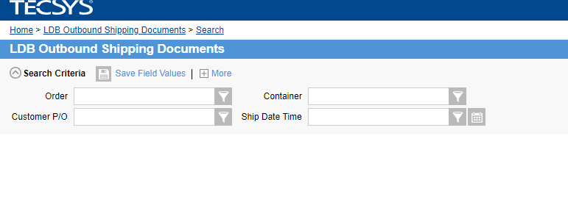

1. Click on the personalize on the bottom right hand corner to personalize the view



1. Under the “Search Criteria” add the Shipment as fifth option and check the “Show on launch” check box

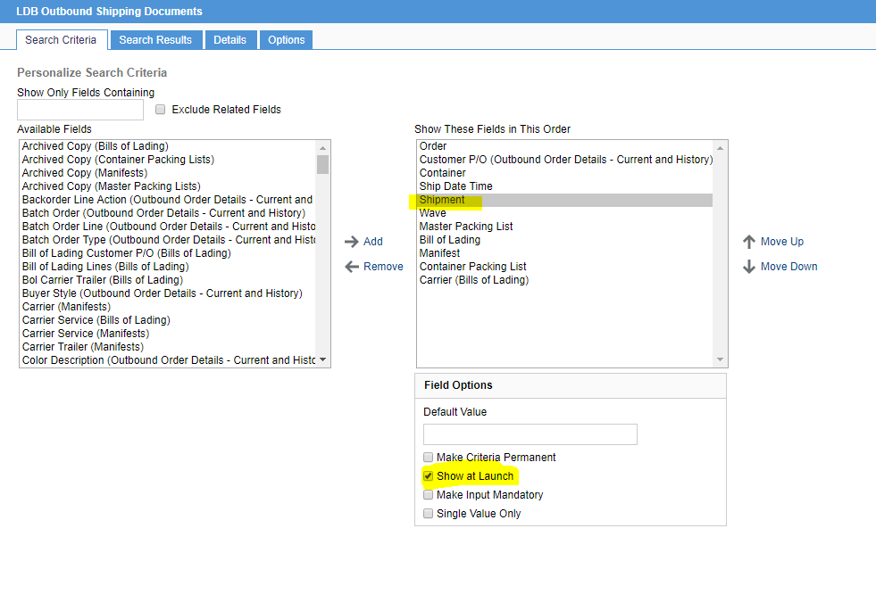

1. Added Carrier from bill of lading as the last option

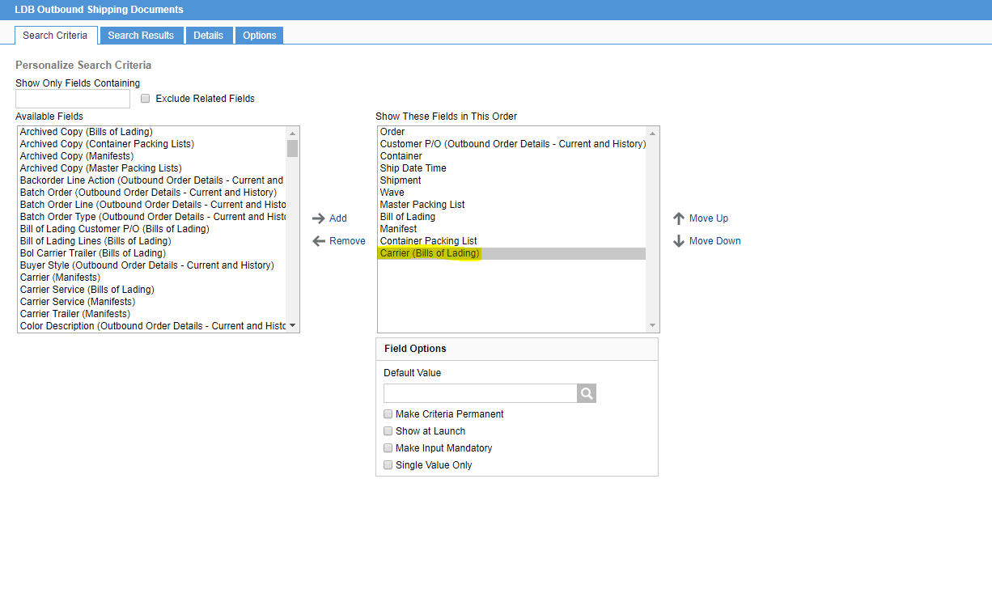

1. Navigate to the search results section and add carrier to the search result

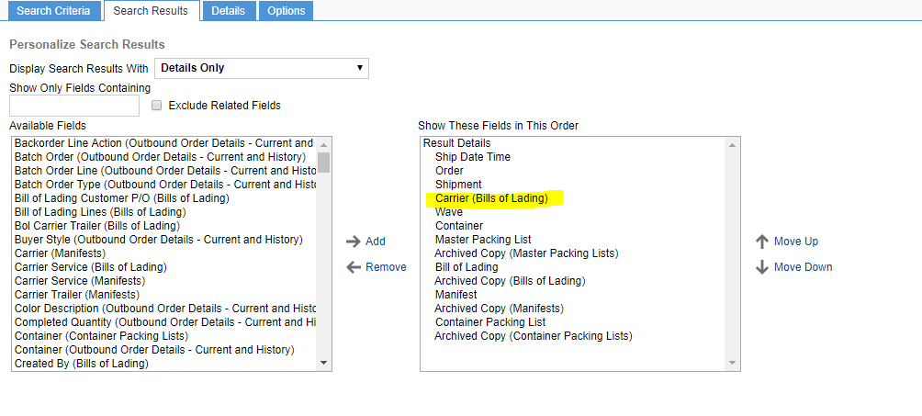

1. Save and Submit to save the changes
2. Notify Sri to do the verification